
AMERICAN INTERNATIONAL
UNIVERSITY BANGLADESH (AIUB)

FACULTY OF SCIENCE & TECHNOLOGY DEPARTMENT OF
ELECTRICAL AND ELECTRONICS ENGINEERING

Spring 2024-2025

DIGITAL LOGIC AND CIRCUITS LABORATORY

Section: D Group: 03

LAB REPORT NAME:
Design and implementation of Astable multivibrators using Timer IC
Supervised By:

S M TANVIR HASSAN SHOVON

Submitted By:

SL | Student ID | Student Name
1. | 23-50856-1 | Basudeb Kundu

Submition Date:22.06.2025

Title : Design and implementation of Astable multivibrators using Timer IC

Theory and Methodology:

Astable Multivibrator: It is also called free running sinusoidal oscillator. An astable multivibrator is simply and oscillator. The astable multivibrator generates a continuous stream of rectangular off-on pulses that switch between two voltage levels. The frequency of the pulses and their duty cycle are dependent upon the RC network values.
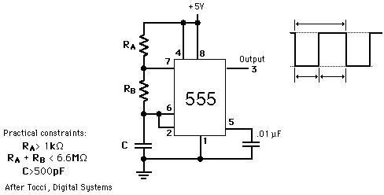

Figure 2: 555 timer connected as an astable multivibrator

The time that the output is high, TL is how long it takes C to discharge from 1/3 of Vcc to 2/3 of Vcc. It is expressed as

TH = 0.7(RA + RB) C
The time that the output is low, TH is how long it takes C to charge from 2/3 of Vcc to 1/3 of Vcc. It is expressed as

TL =0.7RBC

The time period, T = TH + TL = 0.7(RA + 2RB) C Frequency of Oscillation, f = 1/T = 1.44 / (RA + 2RB) C Duty cycle, D = TH/ T = (RA + RB)/ (RA + 2RB) x 100%.
One shot multivibrator: In the one-shot mode, the 555 acts like a monostable multivibrator. A monostable is said to have a single stable state--that is the off state. Whenever it is triggered by an input pulse, the monostable switches to its temporary state. It remains in that state for a period of time determined by an RC network. It then returns to its stable state. In other words, the monostable circuit generates a single pulse of fixed time duration each time it receives and input trigger pulse. Thus the name becomes one-shot. One-shot multivibrators are used for turning some circuit or external component on or off for a specific length of time. It is also used to generate delays. When multiple one-shots are cascaded, a variety of sequential timing pulses can be generated. Those pulses will allow you to time and sequence a number of related operations.

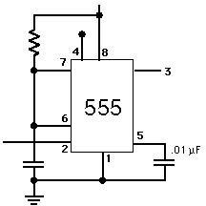
Pulse width of the output is given by T= 1.1 RC (in seconds)

Figure 3: 555 timer connected as a one shot multivibrator

Introduction:

The name of the timer comes from the three 5 kΩ resistors which are embedded in it [1]. This IC gives precise time at the output which is must in the time related circuits. One of its basic operations is to produce clock pulses with predefined frequency as an astable mutivibrator. Another operation is to work like a stop watch which is done in monostable mode. We will see these two operations in this experiment. The following figure is the layout of the 555 Timer IC as which allows us to focus on the functions of the circuit.

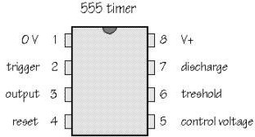

Figure 1: Pin configuration of the 555 timer IC.

Apparatus:
Resistors 1k | 1[pcs]
Resistors 2.2k | 1[pcs]
Resistors 4.7k | 1[pcs]
Resistor 50k | 1[pcs]
Capacitor 0.01u | 1[pcs]
Capacitor 0.022u | 1[pcs]
Capacitor 100u | 1[pcs]
555 Timer IC | 1[pcs]
Precautions:
The DC source should never be turned on before the circuit is correctly placed and carefully checked. Short circuits in the circuit should be checked for thoroughly.

Experimental Procedure:
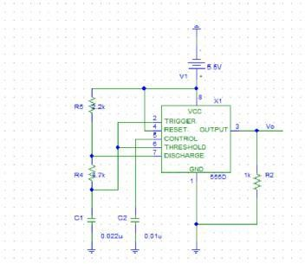
The setups for the astable multivibrator and monostable multivibrator are shown in the following figures.
Figure 4: Experimental setup for astable multivibrator.

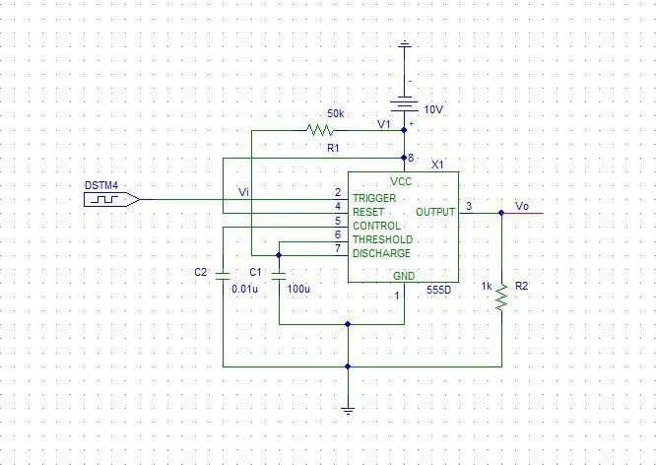

Figure 5: Experimental setup of the monostable multivibrator.

Lab Measuremenet
Astable:
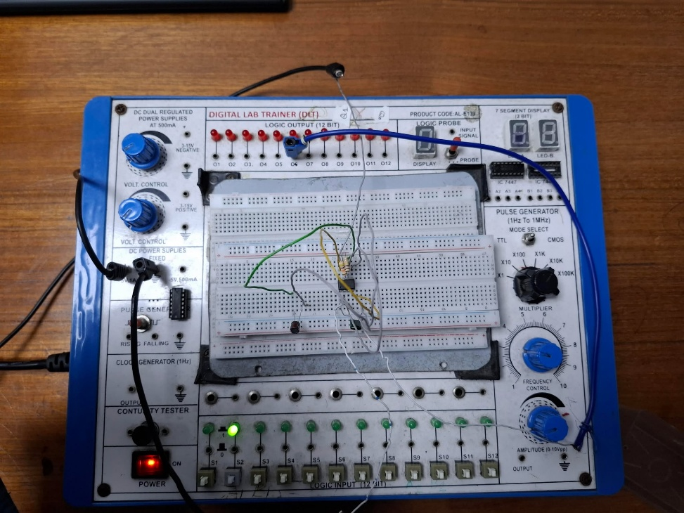

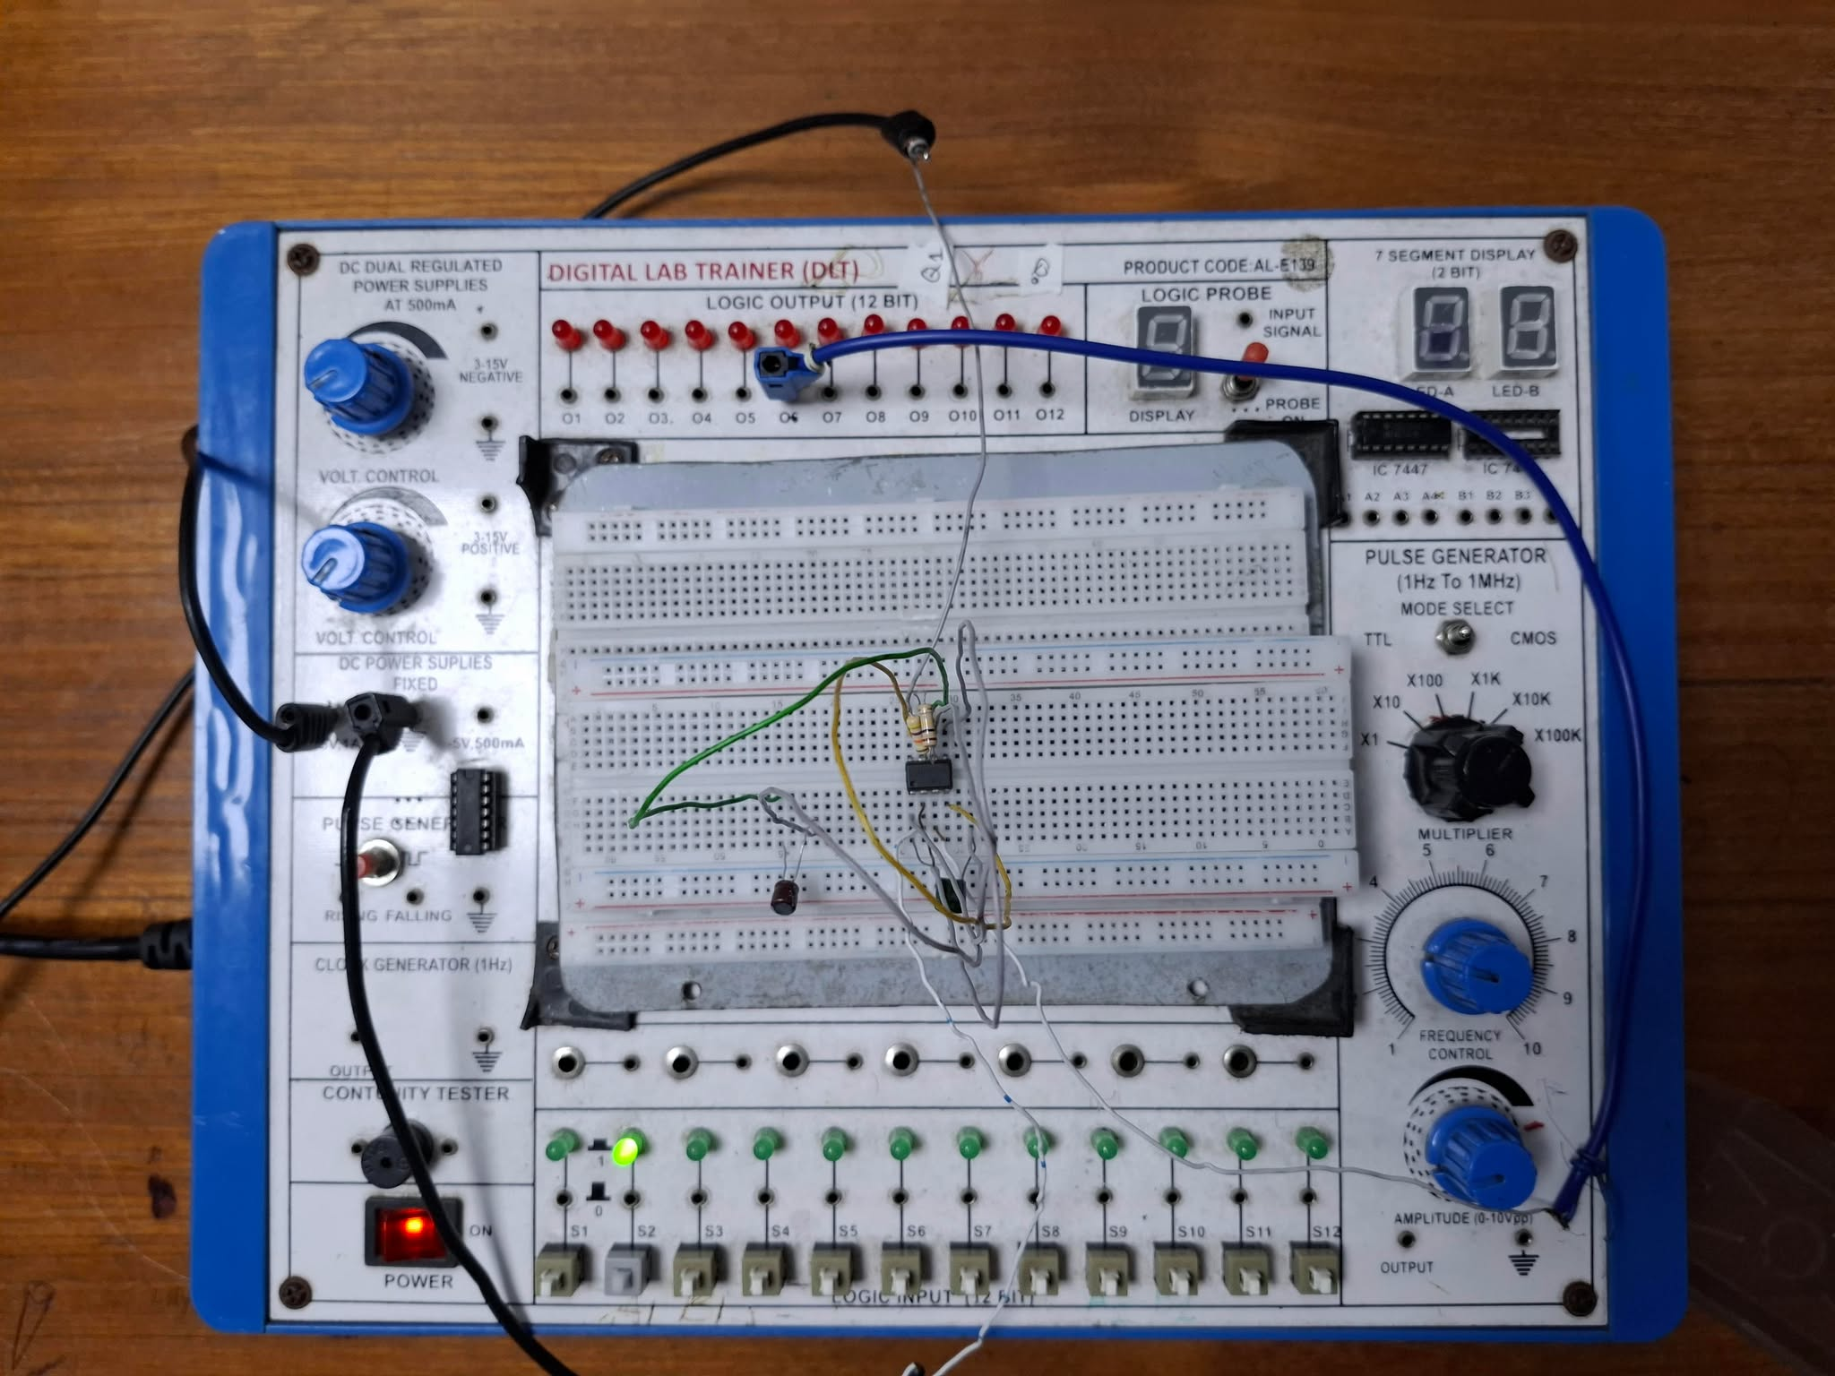
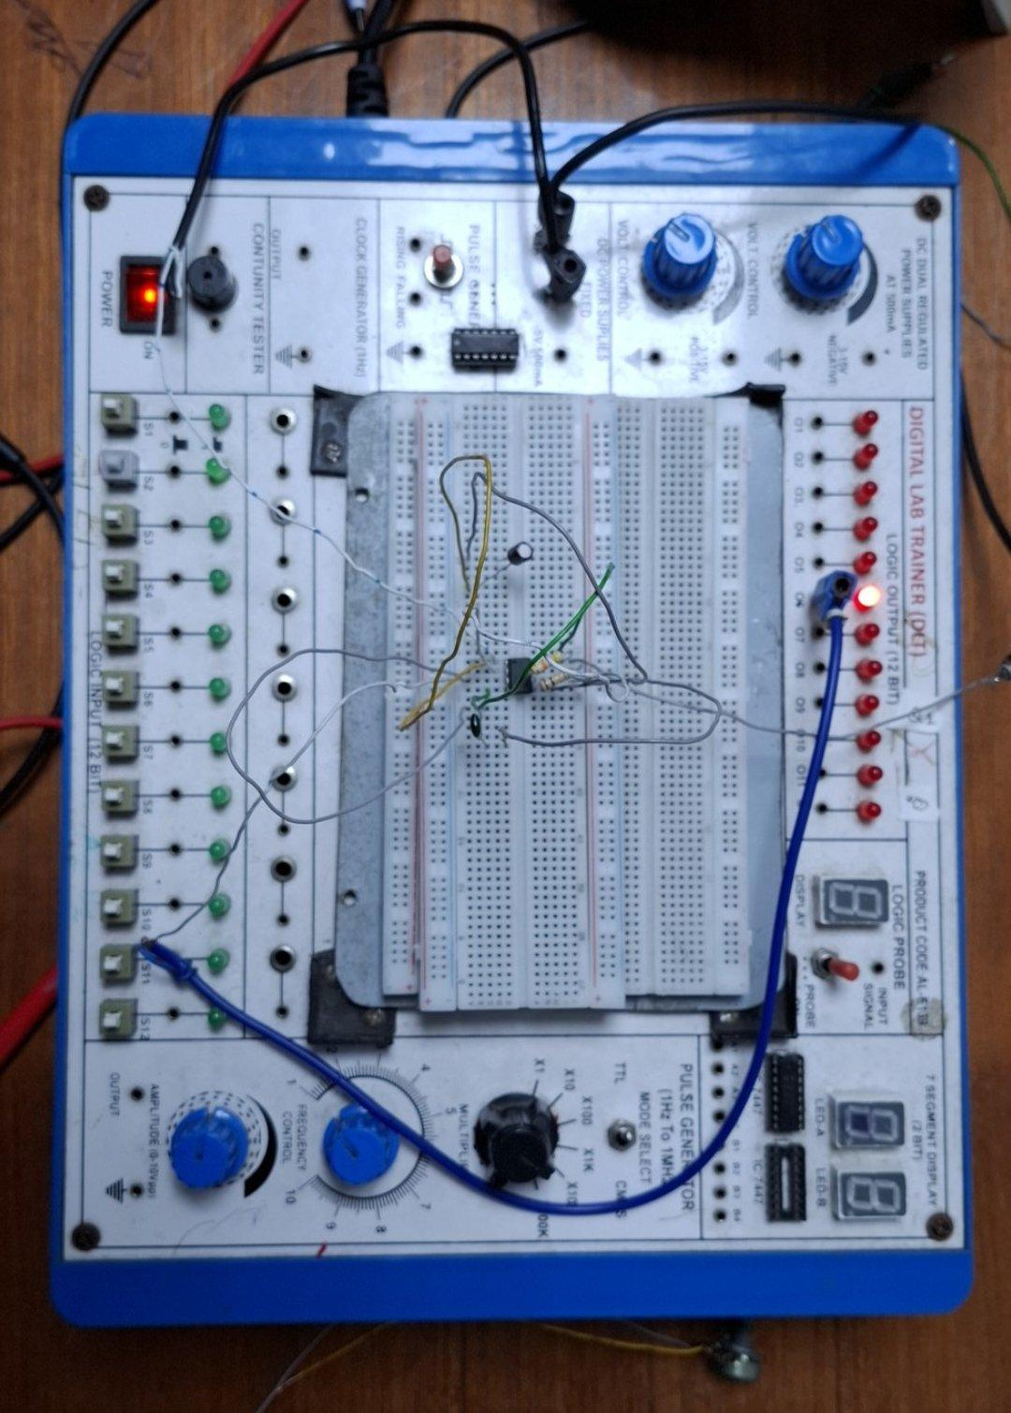

Monstable:
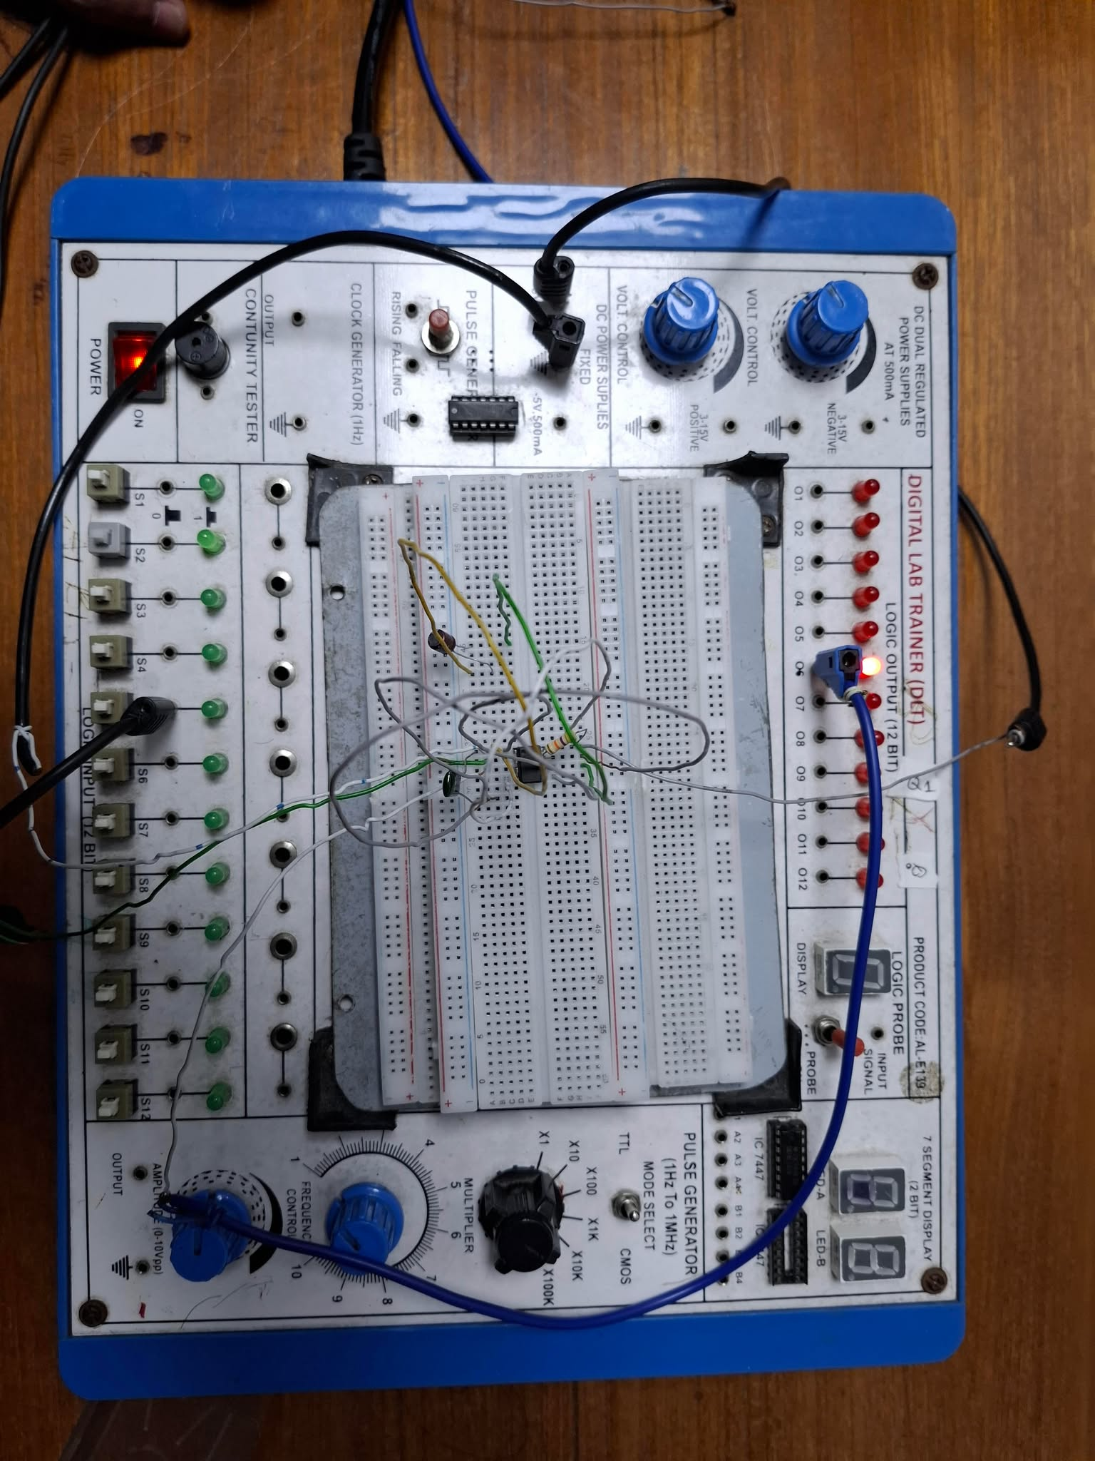
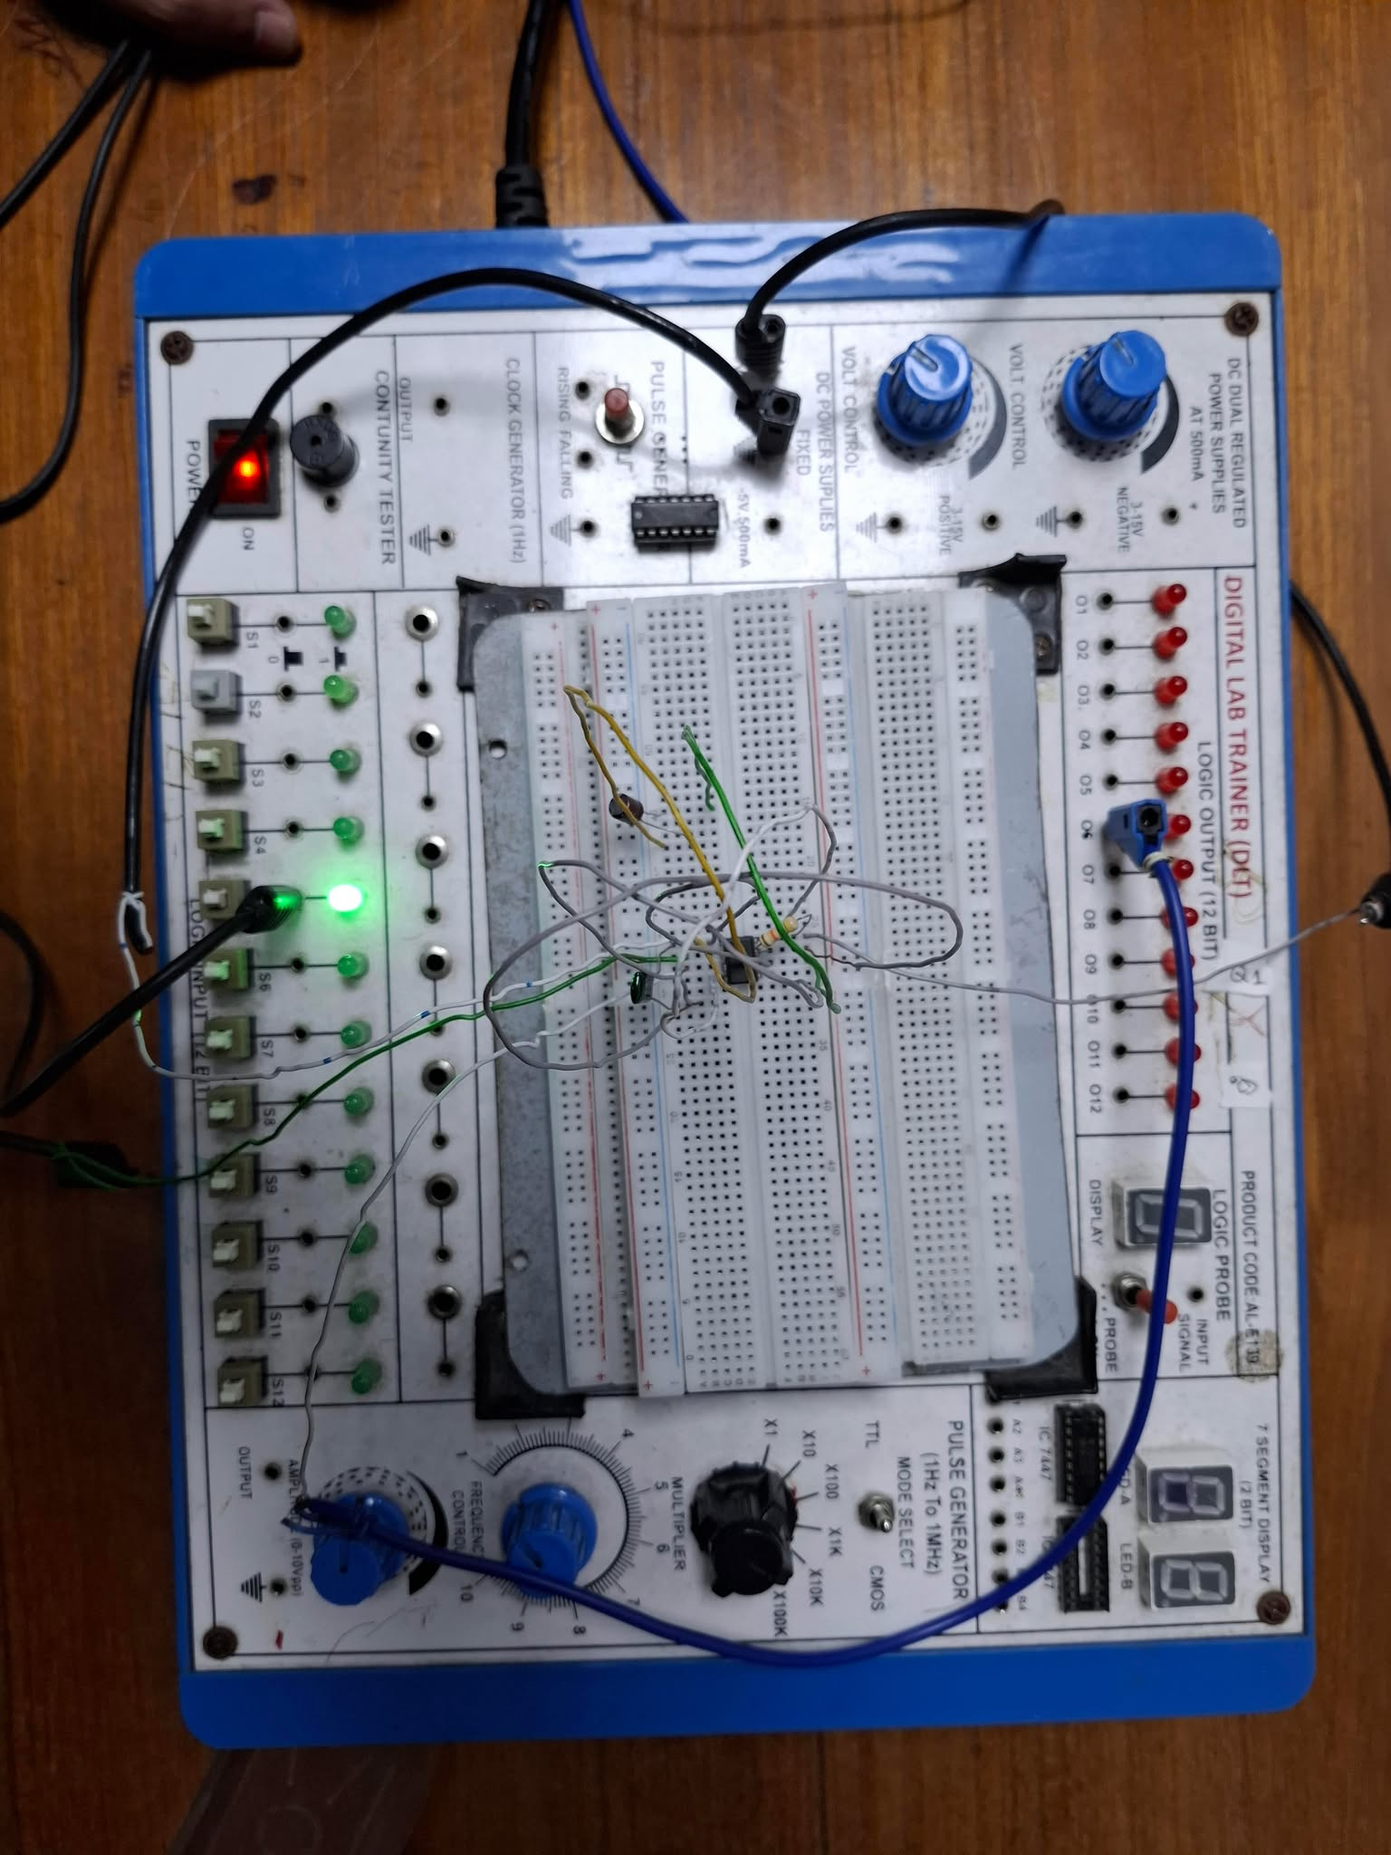

Simulation :
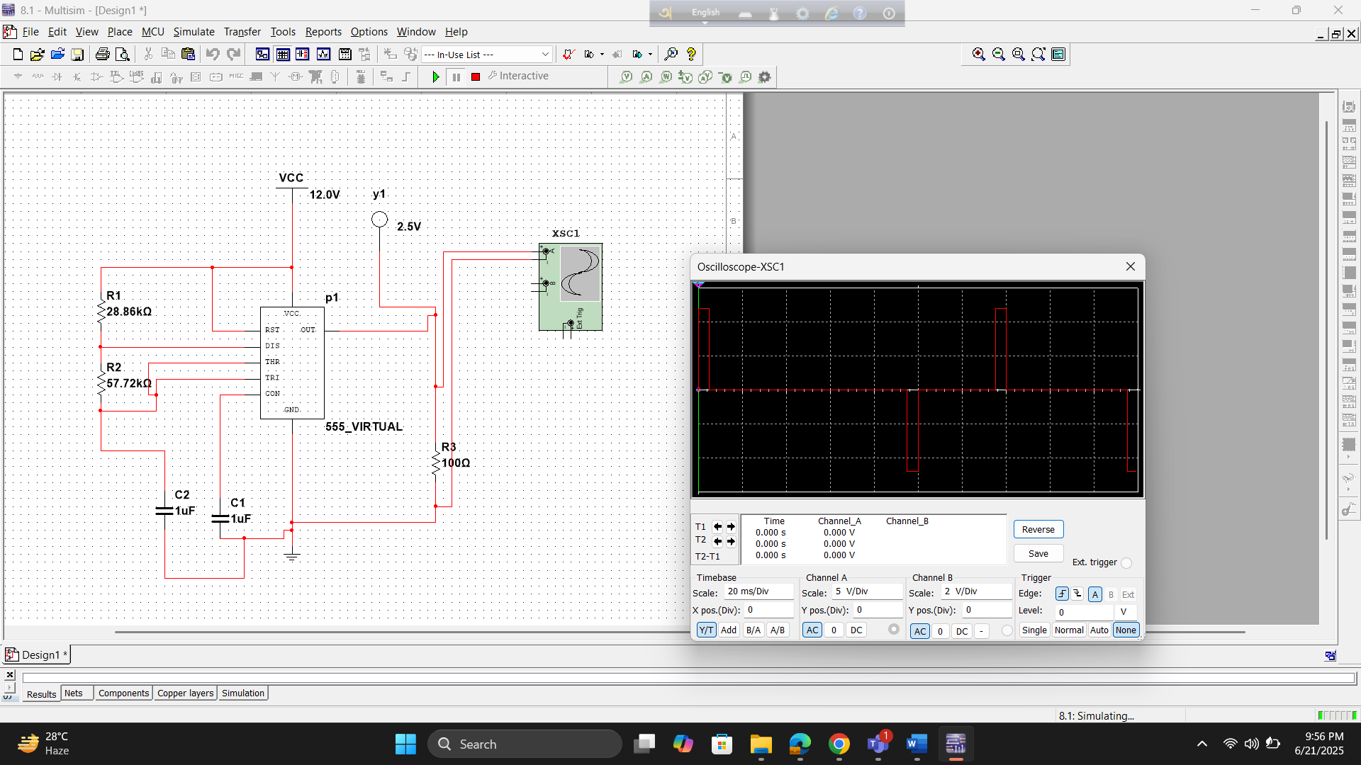
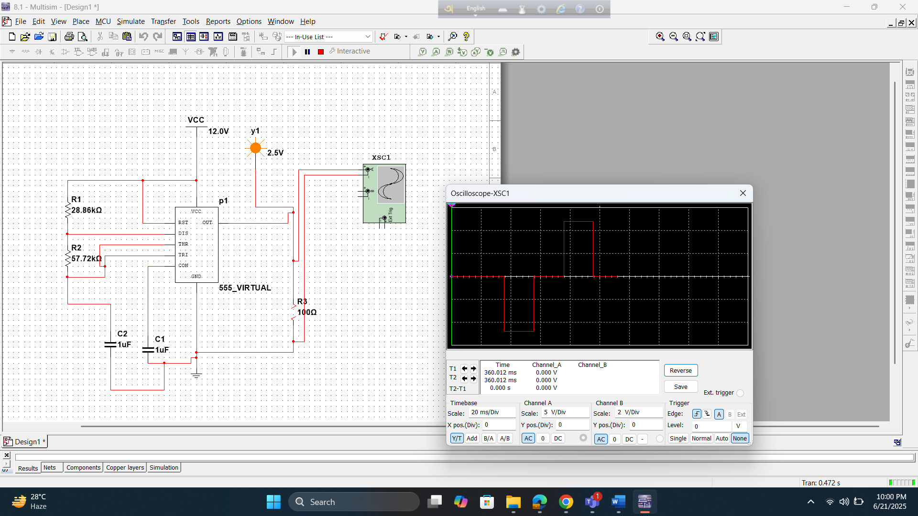
Fig: 555 timers connected as an astable multivibrator

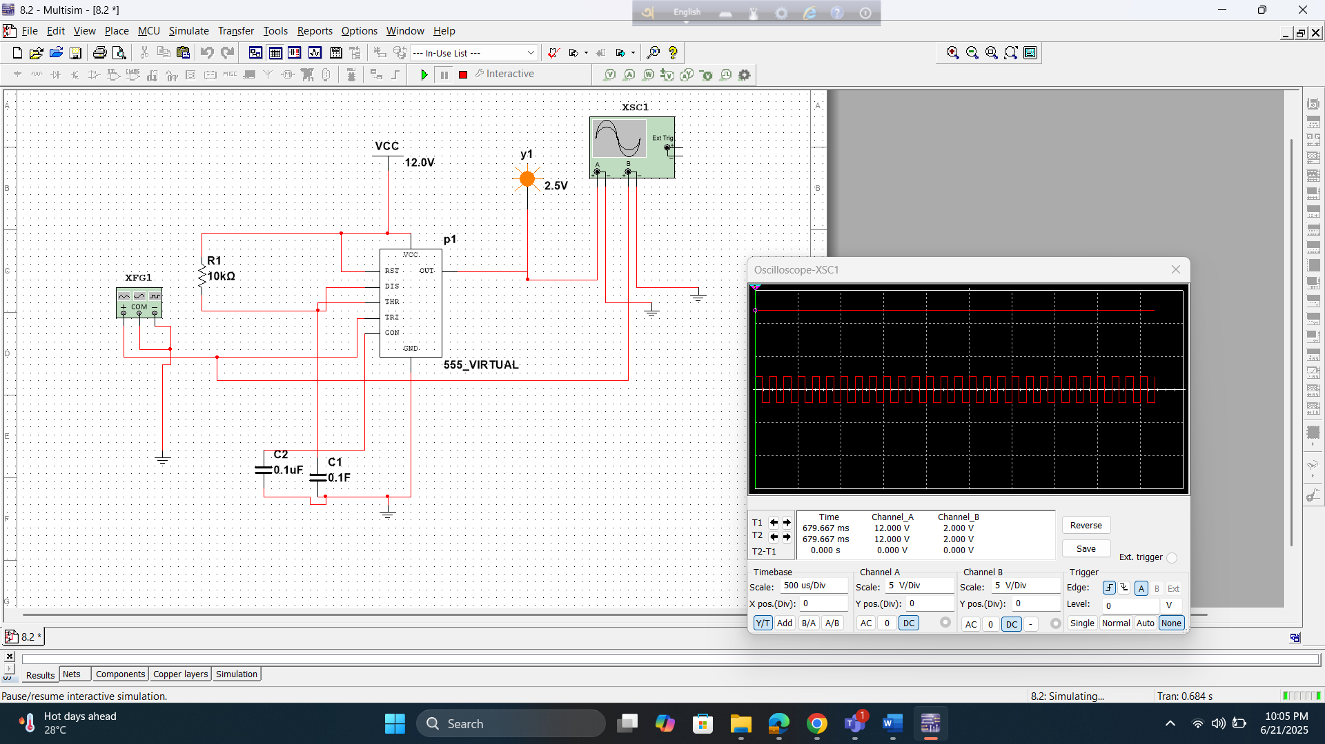
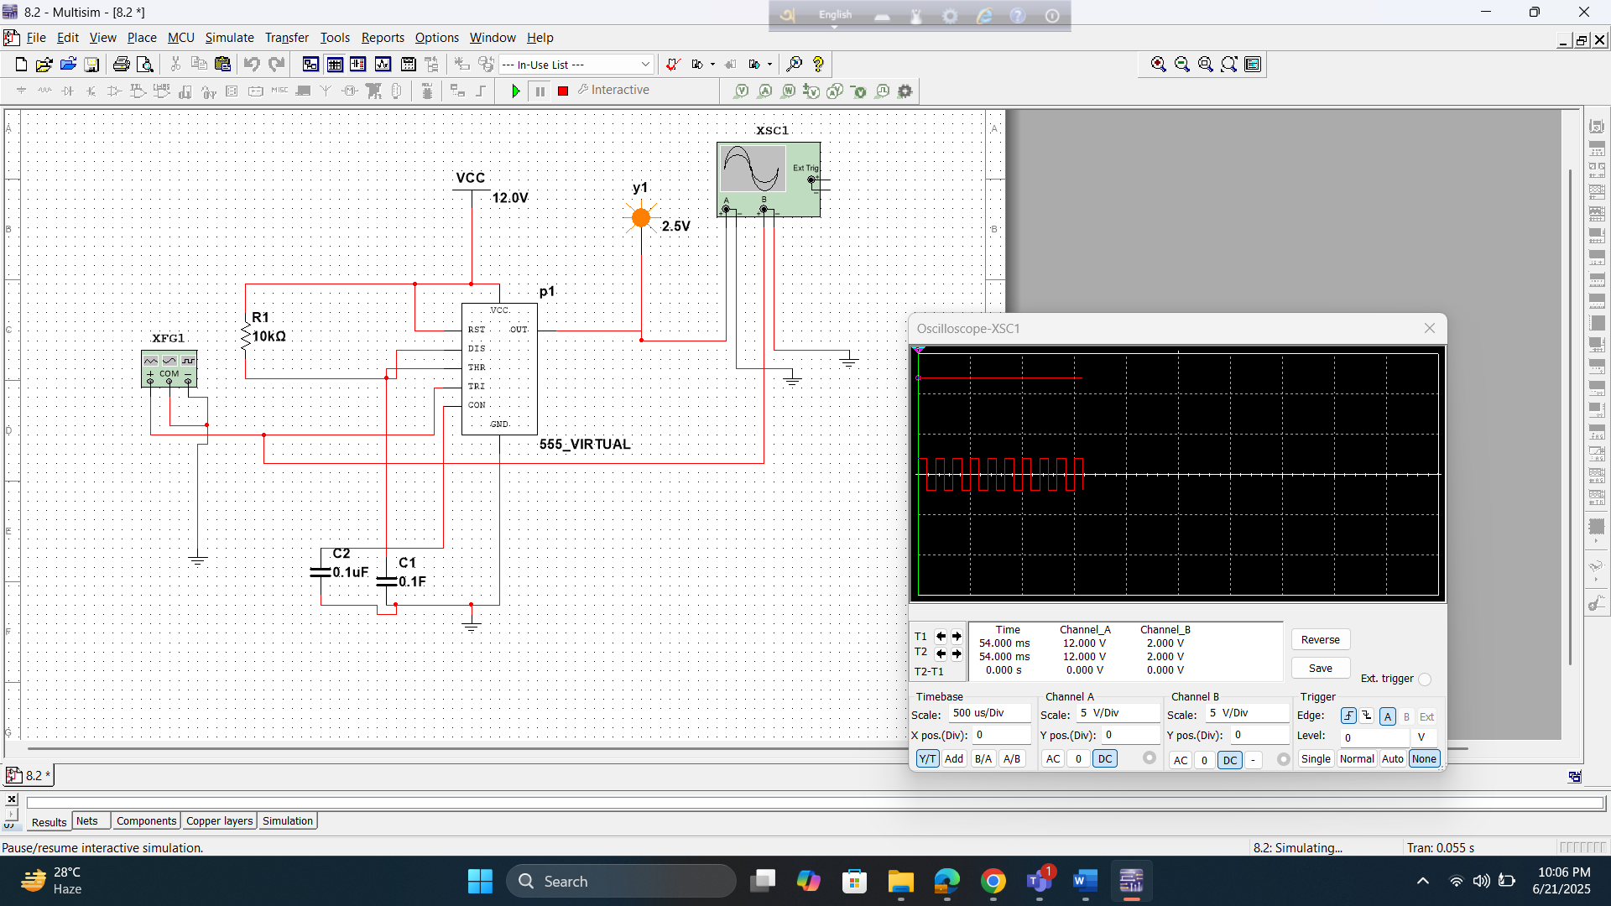
Fig: 555 timer connected as a one shot multivibrator

Result and Findings:
The experiment successfully generated a continuous square wave output from the astable multivibrator circuit built using a 555 Timer IC. The output waveform was verified using both an LED indicator and, where available, an oscilloscope. The periodic blinking of the LED confirmed the generation of a stable and consistent pulse signal.
Key observations and data collected include:
- Output Voltage: The output voltage closely matched the supplied DC voltage, approximately 5V.
- Pulse Timings: The high time (T₁) and low time (T₂) of the output waveform were measured, either through estimation or directly via an oscilloscope.
These measured values were compared against the theoretical predictions using the timing formula:
T = T₁ + T₂ = 0.693 × (R₁ + 2×R₂) × C
The experimental results showed strong alignment with the calculated values, confirming the accuracy of the component selection and overall circuit design. Minor discrepancies observed were attributed to the tolerance of passive components and slight limitations in measurement accuracy.

Reference(s):

- Boylestad, Robert L., and Louis Nashelsky. Electronic Devices And Circuit Theory, 2006, Pearson Prentice Hall.

- Thomas L. Floyd, Digital Fundamentals, 9th Edition, 2006, Prentice Hall.

